Phase I and Phase II Results – Texas (TX)

A. Introduction

B. Plot of Lagged Predictors vs. HPI (simple returns)
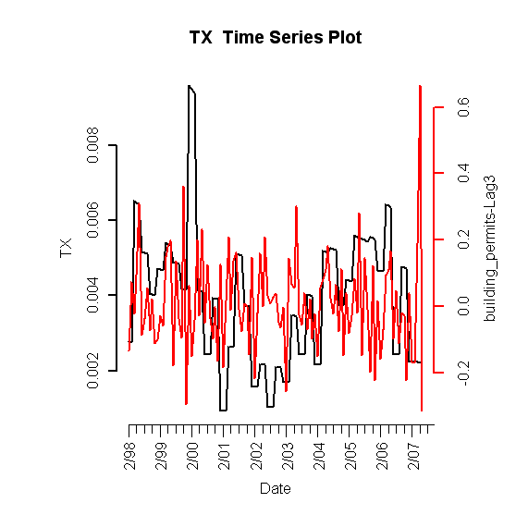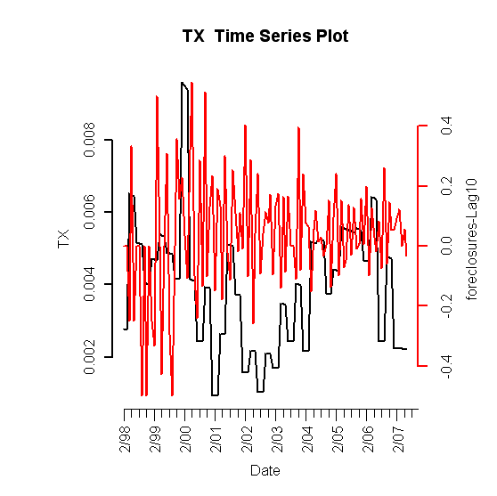
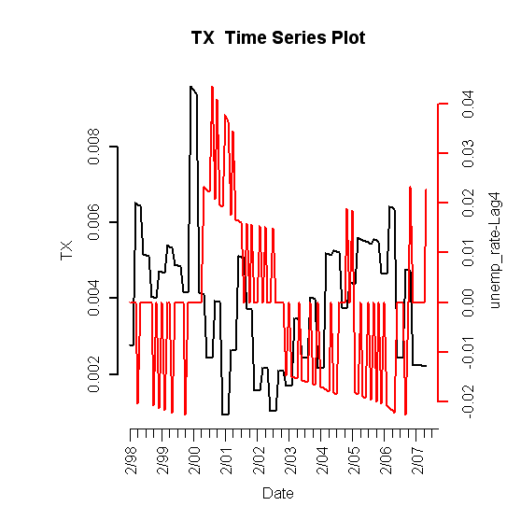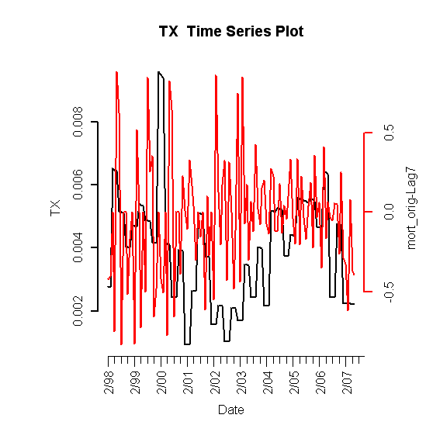
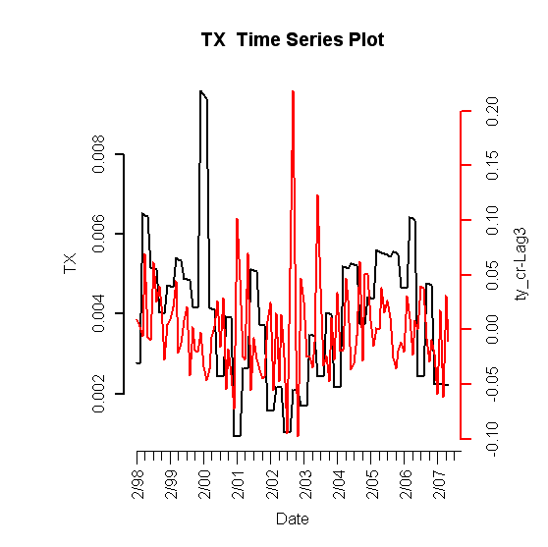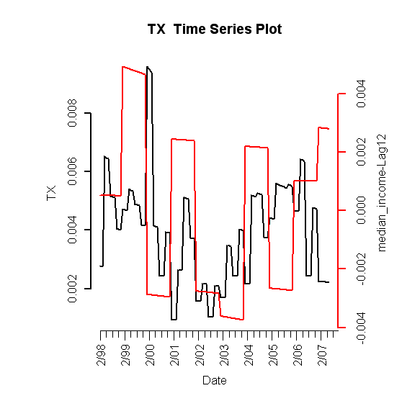
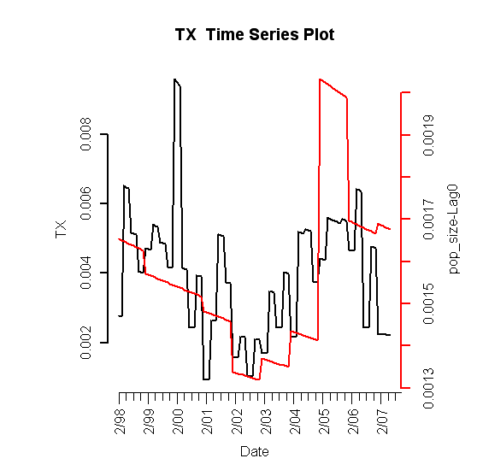

Figure I.1: Lagged predictors vs. Texas HPI

C. Final Multivariate Model

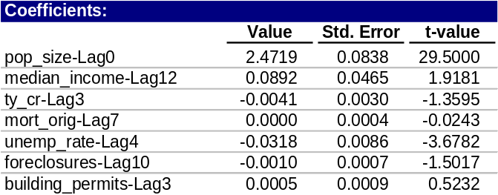
Table 1: Fitted drift model

1. Phase I: Drift Model
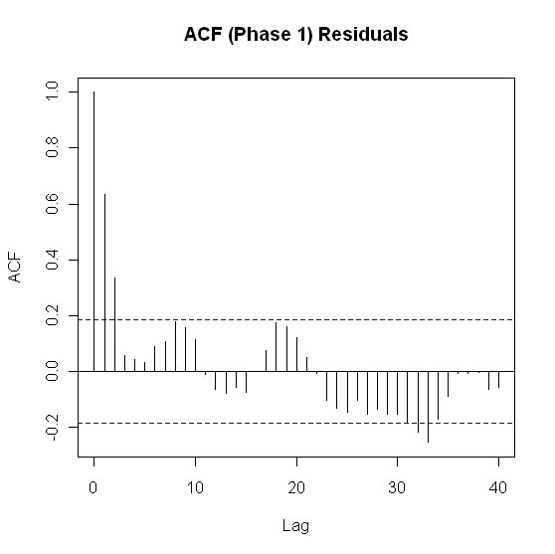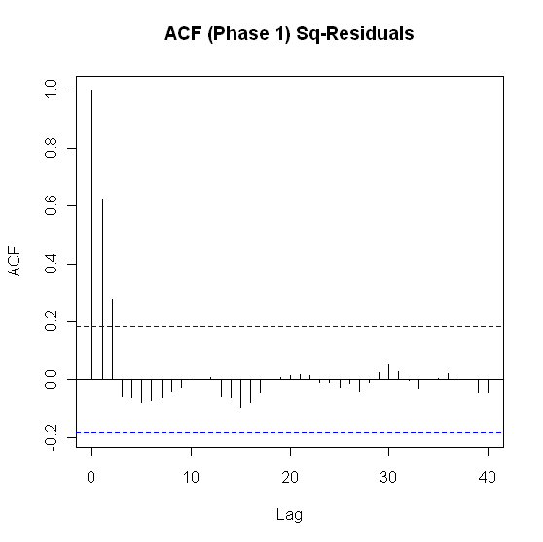

Figure I.2: ACF of residuals (left) and squared residuals (right) of fitted linear model

2. Phase II: Volatility Model

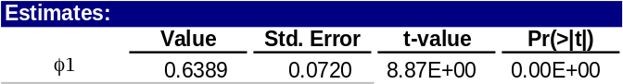
Table 2: Texas fitted volatility model
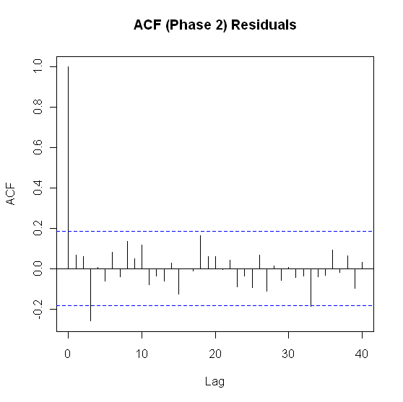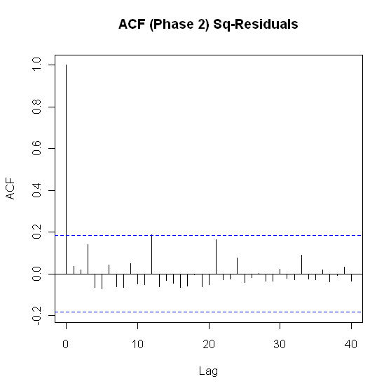

Figure I.3: ACF of residuals (left) and squared residuals (right) of the Phase II model for Texas

3. Model Checking Diagnostics
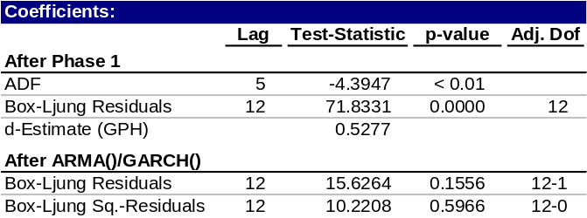
Table 3: Statistical test results for complete model

D. Fitted vs. Actual Plots

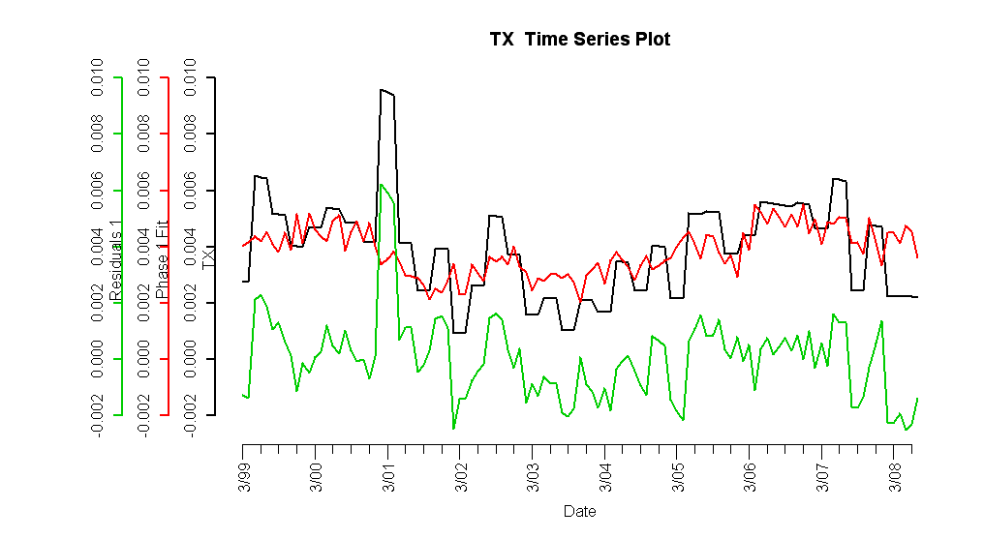

Figure I.4: Fitted Phase I vs. Texas HPI and residuals

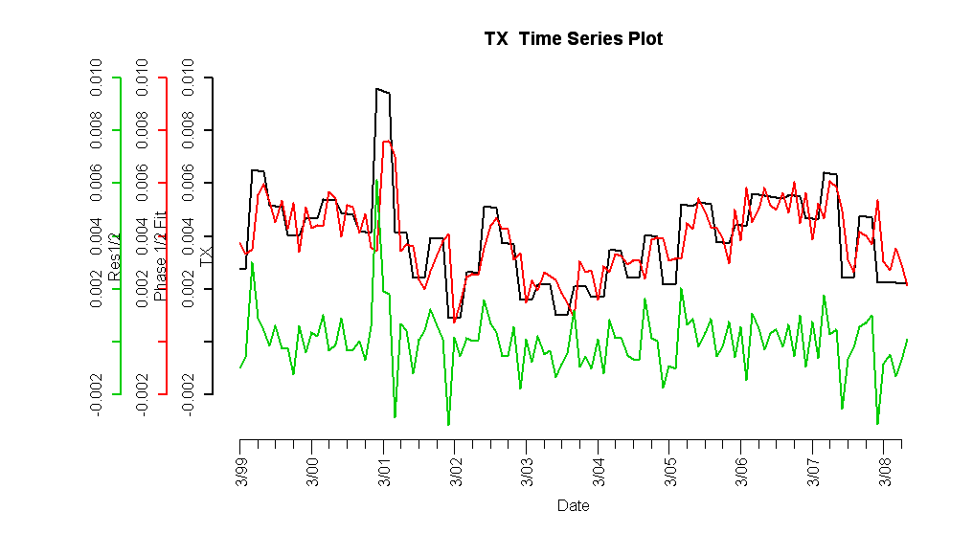

Figure I.5: Complete fitted model vs. Texas HPI and residuals
E. Forecasts

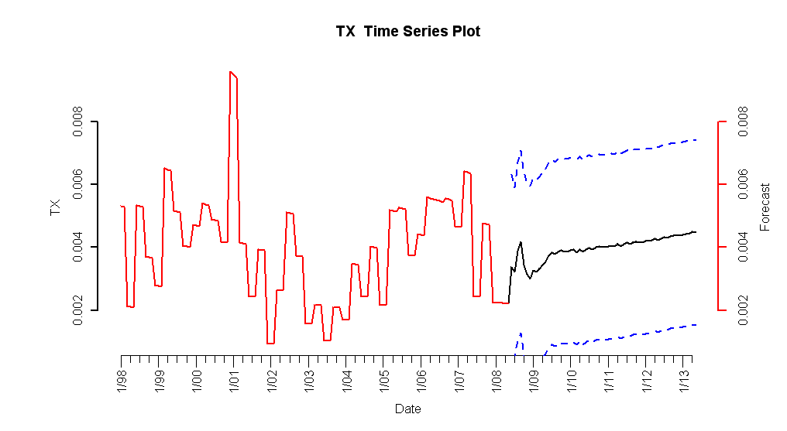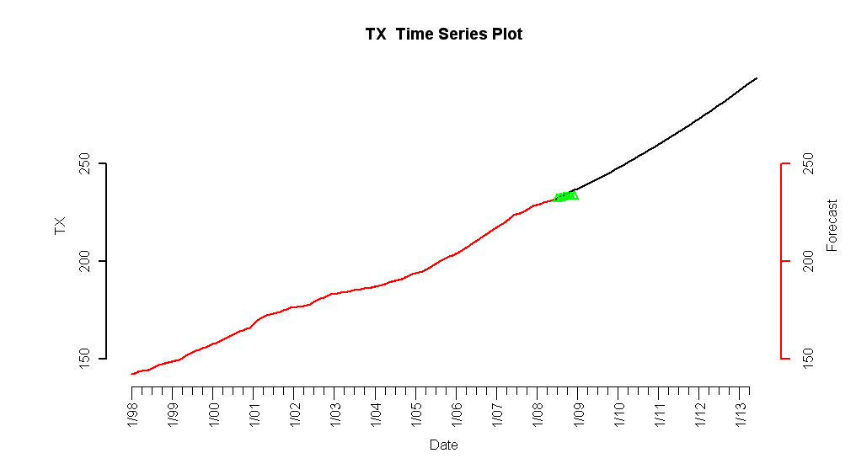
Figure I.6: 5-year forecasted simple returns (top) and forecasted HPI (bottom)

F. Interpretation of Forecasts
The Texas HPI simple return five-year forecasts show a modest positive monthly increase relative to historical simple returns. At 0.5% monthly appreciation, houses will exhibit an annual appreciation of approximately 3%, which is slightly above inflation. Consequently, historical trends in the HPI itself are expected to continue, although at a slightly slower rate. Although construction has slowed considerably in Texas, this will have the effect of keeping inventories from spiking and keeping housing prices stable, if not moderately increasing over the next five years [3].

Texas is fundamentally immune from housing price bubbles, and there are a few key insights that can explain the historically behavior and future projections. Historically and presently, foreclosure rates have been much lower than the national average. However, an exception occurred in the 80’s when Texas experienced an energy bubble, and nine out of the ten largest banks in Texas collapsed due to the subsequent real estate crash. As a result, the credit quality of mortgages have fared better due to stricter lending standards and explicit restrictions on prepayment penalty clauses [2].
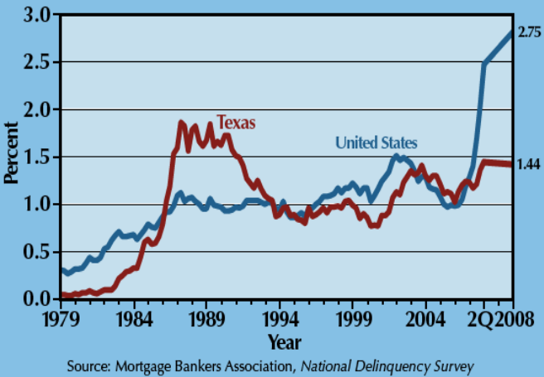
Historical Mortgage Foreclosure Rate
Figure I.7: Historical mortgage foreclosure rate in Texas and the United States.

Recently, Texas has experienced a very low foreclosure rate compared to the nation in the midst of the current housing bubble and correction. The notion that there are two Americas—the coastal regions with dense population densities with zoning and land permit restrictions, and the center states like Kansas, Oklahoma, and Texas—gives rise to the conclusion that speculation and dense populations in states like Florida creates an inelastic supply, and a situation where housing bubbles and happen as a result of lower lending standards and relatively limited housing supply [1].
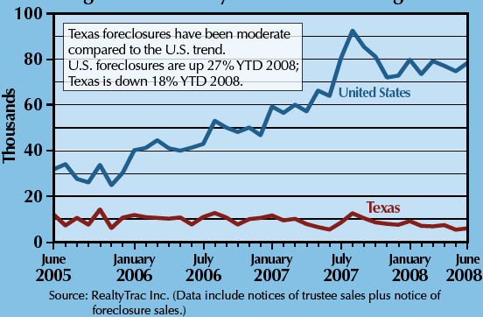
Recent Mortgage Foreclosure Rate
Figure I.8: Recent mortgage foreclosure rate in Texas and the United States.

References
- (New York Times Online) P. Krugman. (2007, October, 7). The two Americas [website]. Available: http://krugman.blogs.nytimes.com/2007/10/20/the-two-americas/
- (Portfolio.com) R. Avent. (2009, April, 21). The two Americas [website]. Available: http://www.portfolio.com/views/blogs/market-movers/2009/04/21/texas-housing-markets-special
- (Research Center Texas A&M University). J. P. Gaines. (2009, April, 21). ’09 Outlook Nothing Certain but Uncertainty [website].Available: http://recenter.tamu.edu/pdf/1891.pdf

